ECRM Report Query Documentation
SQL Schema Reference & Data Dictionary
Database: ecrm_prod | Schema: ecrm, apsis_data | Engine: PostgreSQL (AWS RDS)
Reports Covered
1. Daily Contact Survey Report
2. Live Observation Report (Joint Call)
3. Call Checkback Report
4. Call Center Report

Report Author : MD AHSAMUL HAQUE(Junior Database Engineer Intern)
Supervisor: Rahat Maksud Pranto ( Junior Data Analyst )
Manager: Sohanur Rahman (Senior Data Analyst)

1. Daily Contact Survey Report

1.1 Report Overview
Field | Details
Report Name | Daily Contact Survey Report
Source Table | ecrm.contacts (c)
Filter / Sample ID | c.id = 12429776 (remove for full data set)
Timezone | UTC stored → Asia/Dhaka (UTC+6) for display
Pivot Method | CASE WHEN + MAX() — one row per contact

1.2 Purpose
Generates a comprehensive per-contact record combining contact metadata, full location hierarchy (Outlet to Cluster to Route to Distributor Point to Territory to Area to Region), consumer profile, brand information, timing, and pivoted survey answers. Each row represents one unique contact.

1.3 Location Hierarchy (Bottom to Top)
Alias | Table | Type | Output Column | Notes
r | ecrm.locations | 1 | Region | Highest geography level
l_area | ecrm.locations | 2 | Area | Under Region
l_territory | ecrm.locations | 3 | Territory | Under Area
l_point | ecrm.locations | 5 | Distributorspoint | Distributor point
l_route | ecrm.locations | 6 | Routes | Under Distributor point
l_cluster | ecrm.locations | 7 | Cluster Name | Under Route
l_outlet | ecrm.locations | 8 | Outlets Name / Location ID | Lowest — join anchor

1.4 Output Columns — Full Schema Mapping
Output Column | Source Expression | Table | Notes
Contact ID | c.id | ecrm.contacts | PRIMARY KEY — unique contact identifier
Location ID | l_outlet.id | ecrm.locations (type=8) | Outlet location PK
Region | r.name | ecrm.locations (type=1) | Top-level geography
Area | l_area.name | ecrm.locations (type=2) | —
Territory | l_territory.name | ecrm.locations (type=3) | —
Distributorspoint | l_point.name | ecrm.locations (type=5) | —
Routes | l_route.name | ecrm.locations (type=6) | —
Cluster Name | l_cluster.name | ecrm.locations (type=7) | —
Outlets Name | l_outlet.name | ecrm.locations (type=8) | —
User Name | c.contacted_br | ecrm.contacts | BR username who conducted survey
BR Name | ui.full_name | ecrm.user_infos | Full name of BR
Campaign Name | ca.name | ecrm.campaigns | —
Contact Date | c.contact_date | ecrm.contacts | —
Consumer Number | c.contact_no | ecrm.contacts | Phone number (join key to consumers)
Consumer Name | co.name | ecrm.consumers | —
Consumers fathers_name | co.fathers_name | ecrm.consumers | —
AGE | AGE(current_date, co.dob) | ecrm.consumers | Calculated — interval type
Consumer Address | co.address | ecrm.consumers | —
Consumer Occupation | co.profession | ecrm.consumers | —
Primary Brand | pr.name | ecrm.products | c.product → products.id
Secondary Brand | sr.name | ecrm.products | c.secondary_brand → products.id
Contact Start | TO_CHAR(c.start AT TIME ZONE 'Asia/Dhaka', 'HH24:MI:SS') | ecrm.contacts | Timezone-converted start time
Contact End | TO_CHAR(c.end AT TIME ZONE 'Asia/Dhaka', 'HH24:MI:SS') | ecrm.contacts | Timezone-converted end time
Contact Duration | (c.end - c.start) | ecrm.contacts | Interval = end minus start
Contact Picture / signature | c.signature | ecrm.contacts | S3 URL or filename
asking_about_kit | cs.answer (pivot) | ecrm.contact_survey_data_maps | Survey question pivot
asking_about_music_kit_preference | cs.answer (pivot) | ecrm.contact_survey_data_maps | —
asking_about_travel_kit_preference | cs.answer (pivot) | ecrm.contact_survey_data_maps | —
asking_about_art_kit_preference | cs.answer (pivot) | ecrm.contact_survey_data_maps | —
social_media_info | cs.answer (pivot) | ecrm.contact_survey_data_maps | —

1.5 Join Map
Table | Alias | Join Condition / Role
ecrm.contacts | c | Primary source — all contact records
ecrm.locations (type=8) | l_outlet | INNER JOIN — outlet; c.location_id = l_outlet.id
ecrm.locations (type=7) | l_cluster | LEFT JOIN — parent of outlet
ecrm.locations (type=6) | l_route | LEFT JOIN — parent of cluster
ecrm.locations (type=5) | l_point | LEFT JOIN — parent of route
ecrm.locations (type=3) | l_territory | LEFT JOIN — parent of point
ecrm.locations (type=2) | l_area | LEFT JOIN — parent of territory
ecrm.locations (type=1) | r | LEFT JOIN — parent of area (Region)
ecrm.user_infos | ui | LEFT JOIN — c.user_id = ui.user_id
ecrm.campaigns | ca | LEFT JOIN — c.campaign_id = ca.id
ecrm.consumers | co | LEFT JOIN — c.contact_no = co.contact_no
ecrm.products | pr | LEFT JOIN — c.product = pr.id (primary brand)
ecrm.products | sr | LEFT JOIN — c.secondary_brand = sr.id
ecrm.contact_survey_data_maps | cs | INNER JOIN — c.id = cs.contact_id

1.6 Pivot Logic
Survey answers are stored as key-value rows in ecrm.contact_survey_data_maps (one row per question per contact). The query uses CASE WHEN + MAX() to pivot these rows into columns — without aggregation one contact would produce multiple rows. The Report_Download variant uses separate LEFT JOINs per question (cs1, cs2, cs3) as an alternative pivot approach.

1.7 Common Modifications
Modification | How
Remove single-ID filter | DELETE: WHERE c.id = 12429776
Date range filter | ADD: AND c.contact_date BETWEEN '2025-01-01' AND '2025-12-31'
Campaign filter | ADD: AND ca.name = 'Campaign Name'
Add survey question | ADD: MAX(CASE WHEN cs.question = 'your_question' THEN cs.answer END) AS "your_question" — also add to GROUP BY if not aggregated
Order results | ADD at end: ORDER BY c.contact_date DESC
Limit rows | ADD at end: LIMIT 100

1.8 Full Query
The complete production query for the Daily Contact Survey Report. Copy and run directly against ecrm_prod via the read replica.

SELECT
-- CONTACT IDENTIFIER
c.id AS "Contact ID",
l_outlet.id AS "Location ID",

-- LOCATION HIERARCHY (Region → Outlet)
r.name AS "Region",
l_area.name AS "Area",
l_territory.name AS "Territory",
l_point.name AS "Distributorspoint",
l_route.name AS "Routes",
l_cluster.name AS "Cluster Name",
l_outlet.name AS "Outlets Name",

-- USER & CAMPAIGN
c.contacted_br AS "User Name",
ui.full_name AS "BR Name",
ca.name AS "Campaign Name",

-- CONTACT DETAILS
c.contact_date AS "Contact Date",
c.contact_no AS "Consumer Number",

-- CONSUMER PROFILE
co.name AS "Consumer Name",
co.fathers_name AS "Consumers fathers_name",
AGE(current_date, co.dob) AS "AGE",
co.address AS "Consumer Address",
co.profession AS "Consumer Occupation",

-- BRAND
pr.name AS "Primary Brand",
sr.name AS "Secondary Brand",

-- TIMING (UTC → Asia/Dhaka)
TO_CHAR(c.start AT TIME ZONE 'Asia/Dhaka','HH24:MI:SS') AS "Contact Start",
TO_CHAR(c.end AT TIME ZONE 'Asia/Dhaka','HH24:MI:SS') AS "Contact End",
(c.end - c.start) AS "Contact Duration",
c.signature AS "Contact Picture",

-- SURVEY ANSWERS (PIVOT)
MAX(CASE WHEN cs.question='asking_about_kit'
THEN cs.answer END) AS "asking_about_kit",
MAX(CASE WHEN cs.question='asking_about_music_kit_preference'
THEN cs.answer END) AS "asking_about_music_kit_preference",
MAX(CASE WHEN cs.question='asking_about_travel_kit_preference'
THEN cs.answer END) AS "asking_about_travel_kit_preference",
MAX(CASE WHEN cs.question='asking_about_art_kit_preference'
THEN cs.answer END) AS "asking_about_art_kit_preference",
MAX(CASE WHEN cs.question='social_media_info'
THEN cs.answer END) AS "social_media_info"

FROM ecrm.contacts c

-- OUTLET (type=8) — INNER JOIN required for location chain
JOIN ecrm.locations l_outlet
ON c.location_id = l_outlet.id AND l_outlet.type = 8

-- CLUSTER → ROUTE → POINT → TERRITORY → AREA → REGION
LEFT JOIN ecrm.locations l_cluster ON l_outlet.parent = l_cluster.id AND l_cluster.type = 7
LEFT JOIN ecrm.locations l_route ON l_cluster.parent = l_route.id AND l_route.type = 6
LEFT JOIN ecrm.locations l_point ON l_route.parent = l_point.id AND l_point.type = 5
LEFT JOIN ecrm.locations l_territory ON l_point.parent = l_territory.id AND l_territory.type = 3
LEFT JOIN ecrm.locations l_area ON l_territory.parent = l_area.id AND l_area.type = 2
LEFT JOIN ecrm.locations r ON l_area.parent = r.id AND r.type = 1

LEFT JOIN ecrm.user_infos ui ON c.user_id = ui.user_id
LEFT JOIN ecrm.campaigns ca ON c.campaign_id = ca.id
LEFT JOIN ecrm.consumers co ON c.contact_no = co.contact_no
LEFT JOIN ecrm.products pr ON c.product = pr.id
LEFT JOIN ecrm.products sr ON c.secondary_brand = sr.id

-- SURVEY — all questions in one join, pivoted in SELECT
JOIN ecrm.contact_survey_data_maps cs ON c.id = cs.contact_id

WHERE c.id = 12429776 -- remove for all contacts

GROUP BY
c.id, l_outlet.id, r.name, l_area.name, l_territory.name,
l_point.name, l_route.name, l_cluster.name, l_outlet.name,
c.contacted_br, ui.full_name, ca.name, c.contact_date,
c.contact_no, co.name, co.fathers_name, co.dob,
co.address, co.profession, pr.name, sr.name,
c.start, c.end, c.signature;

1.9 Query Clause-by-Clause Explanation
Each significant clause or expression explained in plain language:

SQL Clause / Expression | What It Does
SELECT c.id AS "Contact ID" | The unique primary key of ecrm.contacts. Every row in the result represents exactly one contact event identified by this ID.
l_outlet.id AS "Location ID" | The outlet location's PK (type=8). Captured separately from the outlet name so downstream systems can do ID-based lookups.
r.name, l_area.name … l_outlet.name | Seven location columns assembled by traversing the parent chain upward from the outlet. Each level is a separate self-join on ecrm.locations filtered by its type number (1=Region, 2=Area, 3=Territory, 5=Point, 6=Route, 7=Cluster, 8=Outlet).
c.contacted_br AS "User Name" | The raw username field stored directly on the contact record — the BR who physically conducted the survey. Does not require a join.
ui.full_name AS "BR Name" | The human-readable full name of the same BR, pulled from ecrm.user_infos via c.user_id to ui.user_id.
AGE(current_date, co.dob) | PostgreSQL built-in that returns an interval (e.g. '28 years 10 mons 7 days'). Calculated fresh at query time — not stored — so it always reflects the consumer's current age.
TO_CHAR(c.start AT TIME ZONE 'Asia/Dhaka', 'HH24:MI:SS') | The contact start timestamp is stored in UTC. AT TIME ZONE 'Asia/Dhaka' shifts it to UTC+6 (Bangladesh Standard Time). TO_CHAR then formats it as HH24:MI:SS for display.
(c.end - c.start) AS "Contact Duration" | Interval arithmetic: PostgreSQL subtracts two timestamps and returns an interval such as '00:06:43'. No function call needed — the minus operator works directly on timestamp columns.
MAX(CASE WHEN cs.question='...' THEN cs.answer END) | Pivot pattern. ecrm.contact_survey_data_maps stores one row per question per contact. Without this, a contact with 5 questions returns 5 rows. CASE WHEN returns the answer only when the question matches (NULL otherwise), and MAX() collapses all rows for the same contact into a single row, picking the one non-NULL value per question column.
FROM ecrm.contacts c | The driving (left-most) table. Every row here is a potential result row. All joins hang off this table.
JOIN ecrm.locations l_outlet ON … AND l_outlet.type = 8 | INNER JOIN — contacts without a matching outlet are excluded entirely. The type=8 filter ensures we only match the Outlet level, not any other location level accidentally sharing the same ID.
LEFT JOIN ecrm.locations l_cluster ON l_outlet.parent = l_cluster.id AND l_cluster.type = 7 | Walks one level up the location tree. parent is a foreign key pointing to the next-higher location. LEFT JOIN means if an outlet has no cluster parent, the contact row still appears (cluster columns are NULL).
LEFT JOIN ecrm.consumers co ON c.contact_no = co.contact_no | Consumer profile is joined by phone number, not by ID. This means if the same phone number has multiple consumer records, multiple rows may be returned — worth checking for duplicates on production data.
LEFT JOIN ecrm.products pr ON c.product = pr.id | Two separate joins on ecrm.products with different aliases (pr for primary, sr for secondary brand). Both resolve the integer brand ID stored on the contact to a human-readable product name.
JOIN ecrm.contact_survey_data_maps cs ON c.id = cs.contact_id | INNER JOIN — contacts with no survey answers are excluded. One survey row per question, so this multiplies rows before GROUP BY collapses them again via MAX(CASE WHEN).
WHERE c.id = 12429776 | Development/testing filter. Remove this line (or replace with a date range) to run the report for all contacts. Without a filter the query may return millions of rows.
GROUP BY c.id, l_outlet.id, … | Required because MAX() is an aggregate function. Every SELECT column that is not inside an aggregate must appear here. The GROUP BY key is effectively c.id — all other columns are functionally dependent on it, but PostgreSQL requires them listed explicitly.

2. Live Observation Report (Joint Call)

2.1 Report Overview
Field | Details
Report Name | Live Observation Report (Joint Call)
Source Table | ecrm.joint_calls (jc)
Filter / Sample ID | jc.id = 444487 (remove for full data set)
Supervisor | jc.user_id → ecrm.users (sup)
BR / FF | jc.ff_id → ecrm.users (br)
Pivot Method | CASE WHEN + MAX() — one row per joint call

2.2 Purpose
Records a supervisor's live observation of a BR (Field Force) conducting a consumer contact. The supervisor evaluates whether the BR followed the correct process: correct cluster, correct attire, shop owner permission, device compliance, correct consumer profile, and full campaign messaging execution. Each row = one joint call observation.

2.3 Cross-Schema Join
This report joins across two database schemas: ecrm (primary CRM data) and apsis_data (distributor/company master data). The join key is l_point.name = dp.name — a name-based match rather than an ID. Ensure point names are consistent across both schemas to avoid missing rows.

2.4 Output Columns — Full Schema Mapping
Output Column | Source Expression | Table | Notes
Contact ID | jc.id | ecrm.joint_calls | PRIMARY KEY
Region | r.name | ecrm.locations (type=1) | —
Area | l_area.name | ecrm.locations (type=2) | —
Territory | l_territory.name | ecrm.locations (type=3) | —
Distributorspoint | l_point.name | ecrm.locations (type=5) | —
Campaign Name | ca.name | ecrm.campaigns | —
Sup ID | sup.username | ecrm.users | Supervisor username
Sup Name | sup_i.full_name | ecrm.user_infos | Supervisor full name
BR ID | br.username | ecrm.users | BR username — from jc.ff_id
BR Name | br_i.full_name | ecrm.user_infos | BR full name
Contact Date | jc.contact_date | ecrm.joint_calls | —
ra_correct_cluster | jcs.answer (pivot) | ecrm.joint_calls_survey_data_maps | Survey pivot
ra_correct_attire | jcs.answer (pivot) | ecrm.joint_calls_survey_data_maps | —
shop_owner_permission | jcs.answer (pivot) | ecrm.joint_calls_survey_data_maps | —
exists_third_part_app | jcs.answer (pivot) | ecrm.joint_calls_survey_data_maps | —
choosing_correct_consumer_profile | jcs.answer (pivot) | ecrm.joint_calls_survey_data_maps | —
telling_about_lucky_strike | jcs.answer (pivot) | ecrm.joint_calls_survey_data_maps | —
showing_av | jcs.answer (pivot) | ecrm.joint_calls_survey_data_maps | —
telling_about_circle | jcs.answer (pivot) | ecrm.joint_calls_survey_data_maps | —
telling_about_circle2 | jcs.answer (pivot) | ecrm.joint_calls_survey_data_maps | —
telling_about_circle3 | jcs.answer (pivot) | ecrm.joint_calls_survey_data_maps | —
showing_Global_stories | jcs.answer (pivot) | ecrm.joint_calls_survey_data_maps | Note: mixed-case key
telling_never_ordinary_story | jcs.answer (pivot) | ecrm.joint_calls_survey_data_maps | —
asking_to_color | jcs.answer (pivot) | ecrm.joint_calls_survey_data_maps | —
showing_kit | jcs.answer (pivot) | ecrm.joint_calls_survey_data_maps | —
telling_about_sticker_pack | jcs.answer (pivot) | ecrm.joint_calls_survey_data_maps | —
telling_about_circle_new_journey | jcs.answer (pivot) | ecrm.joint_calls_survey_data_maps | —

2.5 Join Map
Table | Alias | Join Condition / Role
ecrm.joint_calls | jc | Primary source — supervisor joint call records
ecrm.locations (type=8) | l_outlet | LEFT JOIN — jc.location_id = l_outlet.id
ecrm.locations (type=7) | l_cluster | LEFT JOIN — l_outlet.parent = l_cluster.id
ecrm.locations (type=6) | l_route | LEFT JOIN — l_cluster.parent = l_route.id
ecrm.locations (type=5) | l_point | LEFT JOIN — l_route.parent = l_point.id
ecrm.locations (type=3) | l_territory | LEFT JOIN — l_point.parent = l_territory.id
ecrm.locations (type=2) | l_area | LEFT JOIN — l_territory.parent = l_area.id
ecrm.locations (type=1) | r | LEFT JOIN — l_area.parent = r.id (Region)
ecrm.campaigns | ca | LEFT JOIN — jc.campaign_id = ca.id
apsis_data.distributorspoint | dp | LEFT JOIN — l_point.name = dp.name (cross-schema)
apsis_data.company | co | LEFT JOIN — dp.dsid = co.id
ecrm.users | sup | LEFT JOIN — jc.user_id = sup.id (Supervisor)
ecrm.user_infos | sup_i | LEFT JOIN — sup.id = sup_i.user_id
ecrm.users | br | LEFT JOIN — jc.ff_id = br.id (BR/FF)
ecrm.user_infos | br_i | LEFT JOIN — br.id = br_i.user_id
ecrm.joint_calls_survey_data_maps | jcs | LEFT JOIN — jc.id = jcs.joint_call_id

2.6 Key Differences from Daily Report
Aspect | Daily Report | Live Observation
Primary table | ecrm.contacts | ecrm.joint_calls
BR field | c.user_id | jc.ff_id
Supervisor | Not present | jc.user_id → sup
Survey table | contact_survey_data_maps | joint_calls_survey_data_maps
Consumer data | Full profile (name, age, brand…) | Not captured
Cross-schema | No | Yes — apsis_data

2.7 Full Query
The complete production query for the Live Observation (Joint Call) Report.

SELECT
jc.id AS "Contact ID",

-- LOCATION HIERARCHY
r.name AS "Region",
l_area.name AS "Area",
l_territory.name AS "Territory",
l_point.name AS "Distributorspoint",

-- CAMPAIGN
ca.name AS "Campaign Name",

-- SUPERVISOR
sup.username AS "Sup ID",
sup_i.full_name AS "Sup Name",

-- BR (FIELD FORCE)
br.username AS "BR ID",
br_i.full_name AS "BR Name",

jc.contact_date AS "Contact Date",

-- SURVEY ANSWERS (PIVOT)
MAX(CASE WHEN jcs.question='ra_correct_cluster' THEN jcs.answer END) AS "ra_correct_cluster",
MAX(CASE WHEN jcs.question='ra_correct_attire' THEN jcs.answer END) AS "ra_correct_attire",
MAX(CASE WHEN jcs.question='shop_owner_permission' THEN jcs.answer END) AS "shop_owner_permission",
MAX(CASE WHEN jcs.question='exists_third_part_app' THEN jcs.answer END) AS "exists_third_part_app",
MAX(CASE WHEN jcs.question='choosing_correct_consumer_profile' THEN jcs.answer END) AS "choosing_correct_consumer_profile",
MAX(CASE WHEN jcs.question='telling_about_lucky_strike' THEN jcs.answer END) AS "telling_about_lucky_strike",
MAX(CASE WHEN jcs.question='showing_av' THEN jcs.answer END) AS "showing_av",
MAX(CASE WHEN jcs.question='telling_about_circle' THEN jcs.answer END) AS "telling_about_circle",
MAX(CASE WHEN jcs.question='telling_about_circle2' THEN jcs.answer END) AS "telling_about_circle2",
MAX(CASE WHEN jcs.question='telling_about_circle3' THEN jcs.answer END) AS "telling_about_circle3",
MAX(CASE WHEN jcs.question='showing_Global_stories' THEN jcs.answer END) AS "showing_Global_stories",
MAX(CASE WHEN jcs.question='telling_never_ordinary_story' THEN jcs.answer END) AS "telling_never_ordinary_story",
MAX(CASE WHEN jcs.question='asking_to_color' THEN jcs.answer END) AS "asking_to_color",
MAX(CASE WHEN jcs.question='showing_kit' THEN jcs.answer END) AS "showing_kit",
MAX(CASE WHEN jcs.question='telling_about_sticker_pack' THEN jcs.answer END) AS "telling_about_sticker_pack",
MAX(CASE WHEN jcs.question='telling_about_circle_new_journey' THEN jcs.answer END) AS "telling_about_circle_new_journey"

FROM ecrm.joint_calls jc

-- LOCATION CHAIN (Outlet → Region)
LEFT JOIN ecrm.locations l_outlet ON jc.location_id = l_outlet.id AND l_outlet.type = 8
LEFT JOIN ecrm.locations l_cluster ON l_outlet.parent = l_cluster.id AND l_cluster.type = 7
LEFT JOIN ecrm.locations l_route ON l_cluster.parent = l_route.id AND l_route.type = 6
LEFT JOIN ecrm.locations l_point ON l_route.parent = l_point.id AND l_point.type = 5
LEFT JOIN ecrm.locations l_territory ON l_point.parent = l_territory.id AND l_territory.type = 3
LEFT JOIN ecrm.locations l_area ON l_territory.parent = l_area.id AND l_area.type = 2
LEFT JOIN ecrm.locations r ON l_area.parent = r.id AND r.type = 1

LEFT JOIN ecrm.campaigns ca ON jc.campaign_id = ca.id

-- CROSS-SCHEMA: apsis_data (name-based match)
LEFT JOIN apsis_data.distributorspoint dp ON l_point.name = dp.name
LEFT JOIN apsis_data.company co ON dp.dsid = co.id

-- SUPERVISOR
LEFT JOIN ecrm.users sup ON jc.user_id = sup.id
LEFT JOIN ecrm.user_infos sup_i ON sup.id = sup_i.user_id

-- BR / FIELD FORCE (jc.ff_id — different from daily report's user_id)
LEFT JOIN ecrm.users br ON jc.ff_id = br.id
LEFT JOIN ecrm.user_infos br_i ON br.id = br_i.user_id

LEFT JOIN ecrm.joint_calls_survey_data_maps jcs ON jc.id = jcs.joint_call_id

WHERE jc.id = 444487 -- remove for all joint calls

GROUP BY
jc.id, r.name, l_area.name, l_territory.name, l_point.name,
ca.name, sup.username, sup_i.full_name,
br.username, br_i.full_name, jc.contact_date;

2.8 Query Clause-by-Clause Explanation

SQL Clause / Expression | What It Does
FROM ecrm.joint_calls jc | The primary table for this report. Each row is one supervisor joint call — a live field visit where the supervisor accompanies and evaluates a BR. Not the same as a BR's own contact record.
LEFT JOIN ecrm.locations l_outlet ON jc.location_id = l_outlet.id AND l_outlet.type = 8 | Unlike the Daily Report which uses INNER JOIN for the outlet, this report uses LEFT JOIN throughout the entire location chain. A joint call record missing a location will still appear — location columns will be NULL.
l_outlet.parent = l_cluster.id AND l_cluster.type = 7 | The self-referential join pattern: every location record has a parent column pointing to the next level up. The type filter (7, 6, 5, 3, 2, 1) ensures each alias only matches its intended level — without it, a single location ID could match multiple levels.
LEFT JOIN apsis_data.distributorspoint dp ON l_point.name = dp.name | Cross-schema join to the apsis_data database. Crucially, this joins on name (text), not on an ID. If a distributor point name is spelled differently in the two schemas (spaces, capitalisation, trailing characters), the join silently returns NULL. Always verify name consistency when distributor data is missing.
LEFT JOIN apsis_data.company co ON dp.dsid = co.id | Second cross-schema join — follows from the distributorspoint join to resolve the parent company. If dp is NULL (name mismatch above), co will also be NULL automatically.
LEFT JOIN ecrm.users sup ON jc.user_id = sup.id | jc.user_id identifies the SUPERVISOR who conducted the observation — different from the Daily Report where user_id is the BR. This semantic difference is critical: swapping the fields would attribute supervisor actions to the BR.
LEFT JOIN ecrm.users br ON jc.ff_id = br.id | jc.ff_id (Field Force ID) identifies the BR being observed. The field name ff_id is the only way to distinguish supervisor from BR in this table — there is no 'role' column.
jcs.question = 'showing_Global_stories' | WARNING: This question key uses mixed case — capital G in 'Global'. The equivalent key in the Call Checkback report uses all-lowercase 'showing_global_series'. If you filter or search by question key across reports, match the exact case for each report.
LEFT JOIN ecrm.joint_calls_survey_data_maps jcs ON jc.id = jcs.joint_call_id | Survey data for joint calls is stored in a separate table from the Daily Report's contact_survey_data_maps. The join column is joint_call_id (not contact_id). Using the wrong survey table would silently return no survey answers.
WHERE jc.id = 444487 | Development filter for a single joint call. Remove for production runs. Consider adding a date filter: AND jc.contact_date = '2025-07-14'.
GROUP BY jc.id, r.name, …, jc.contact_date | All non-aggregated SELECT columns must appear here. The minimal unique key is jc.id, but PostgreSQL requires every column listed. The contact_date is included because it may vary per joint_call_id in edge cases.

3. Call Checkback Report

3.1 Report Overview
Field | Details
Report Name | Call Checkback Report (Supervisor Contact Verification)
Source Table | ecrm.supervisor_contacts (sc)
Filter / Sample ID | sc.id = 495011 (remove for full data set)
Supervisor | sc.user_id → ecrm.users (sup)
BR | sc.br_id → ecrm.users (br)
Contact Match | sc.contact + sc.br_id + sc.campaign_id + sc.contact_date = ecrm.contacts
Pivot Method | CASE WHEN + MAX() — one row per supervisor contact

3.2 Purpose
A supervisor calls back consumers after a BR contact to verify whether the consumer actually received the call, whether they were willing to talk, and whether the BR correctly communicated all campaign messages. This is a post-contact quality audit — the supervisor validates the BR's earlier work.

3.3 Four-Key Contact Match
Unlike the other reports, this report links supervisor contacts back to original BR contacts via a composite four-column join on ecrm.contacts — matching contact phone number, BR ID, campaign ID, and contact date together. This is critical: a mismatch on any one of the four keys means no location data will appear for that row.

3.4 Output Columns — Full Schema Mapping
Output Column | Source Expression | Table | Notes
Contact ID | sc.id | ecrm.supervisor_contacts | PRIMARY KEY of supervisor contact
Region | re.name | ecrm.locations (type=1) | —
Area | ar.name | ecrm.locations (type=2) | —
Territory | ter.name | ecrm.locations (type=3) | —
Distributorspoint | po.name | ecrm.locations (type=5) | —
Campaign Name | cm.name | ecrm.campaigns | —
Sup ID | sup.username | ecrm.users | Supervisor username
Sup Name | sup_i.full_name | ecrm.user_infos | —
BR ID | br.username | ecrm.users | BR — from sc.br_id
BR Name | br_i.full_name | ecrm.user_infos | —
Contact Date | sc.contact_date | ecrm.supervisor_contacts | —
receive_call | scs.answer (pivot) | ecrm.supervisor_contact_survey_data_maps | Survey pivot
continue_conversation | scs.answer (pivot) | ecrm.supervisor_contact_survey_data_maps | —
correct_consumer_name | scs.answer (pivot) | ecrm.supervisor_contact_survey_data_maps | —
correct_consumer_age | scs.answer (pivot) | ecrm.supervisor_contact_survey_data_maps | —
correct_primary_brand | scs.answer (pivot) | ecrm.supervisor_contact_survey_data_maps | —
contacted_by_ra | scs.answer (pivot) | ecrm.supervisor_contact_survey_data_maps | —
telling_about_lucky_strike | scs.answer (pivot) | ecrm.supervisor_contact_survey_data_maps | —
showing_av | scs.answer (pivot) | ecrm.supervisor_contact_survey_data_maps | —
telling_about_circle | scs.answer (pivot) | ecrm.supervisor_contact_survey_data_maps | —
telling_about_circle2 | scs.answer (pivot) | ecrm.supervisor_contact_survey_data_maps | —
telling_about_circle3 | scs.answer (pivot) | ecrm.supervisor_contact_survey_data_maps | —
showing_global_series | scs.answer (pivot) | ecrm.supervisor_contact_survey_data_maps | Note: lowercase 'g' (vs Live Obs. 'G')
telling_never_ordinary_story | scs.answer (pivot) | ecrm.supervisor_contact_survey_data_maps | —
asking_to_color | scs.answer (pivot) | ecrm.supervisor_contact_survey_data_maps | —
showing_kit | scs.answer (pivot) | ecrm.supervisor_contact_survey_data_maps | —
telling_about_sticker_pack | scs.answer (pivot) | ecrm.supervisor_contact_survey_data_maps | —
telling_about_circle_new_journey | scs.answer (pivot) | ecrm.supervisor_contact_survey_data_maps | —

3.5 Join Map
Table | Alias | Join Condition / Role
ecrm.supervisor_contacts | sc | Primary source — supervisor verification records
ecrm.contacts | c | LEFT JOIN — 4-key match: contact_no + br_id + campaign_id + contact_date
ecrm.locations (type=8) | ou | LEFT JOIN — c.location_id = ou.id
ecrm.locations (type=7) | cl | LEFT JOIN — ou.parent = cl.id
ecrm.locations (type=6) | ro | LEFT JOIN — cl.parent = ro.id
ecrm.locations (type=5) | po | LEFT JOIN — ro.parent = po.id
ecrm.locations (type=3) | ter | LEFT JOIN — po.parent = ter.id
ecrm.locations (type=2) | ar | LEFT JOIN — ter.parent = ar.id
ecrm.locations (type=1) | re | LEFT JOIN — ar.parent = re.id (Region)
apsis_data.distributorspoint | dp | LEFT JOIN — po.source_id = dp.id (ID-based, not name)
apsis_data.company | co | LEFT JOIN — dp.dsid = co.id
ecrm.users | sup | LEFT JOIN — sc.user_id = sup.id (Supervisor)
ecrm.user_infos | sup_i | LEFT JOIN — sup.id = sup_i.user_id
ecrm.users | br | LEFT JOIN — sc.br_id = br.id (BR)
ecrm.user_infos | br_i | LEFT JOIN — br.id = br_i.user_id
ecrm.campaigns | cm | LEFT JOIN — sc.campaign_id = cm.id
ecrm.supervisor_contact_survey_data_maps | scs | LEFT JOIN — sc.id = scs.sup_contact_id

3.6 apsis_data Join Difference
In this report, the apsis_data join uses po.source_id = dp.id (an ID-based match). In the Live Observation report, the same join uses l_point.name = dp.name (a name-based match). Be aware of this difference when troubleshooting missing distributor data.

3.7 Full Query
The complete production query for the Call Checkback Report.

SELECT
sc.id AS "Contact ID",

-- LOCATION HIERARCHY
re.name AS "Region",
ar.name AS "Area",
ter.name AS "Territory",
po.name AS "Distributorspoint",

-- CAMPAIGN
cm.name AS "Campaign Name",

-- SUPERVISOR
sup.username AS "Sup ID",
sup_i.full_name AS "Sup Name",

-- BR
br.username AS "BR ID",
br_i.full_name AS "BR Name",

sc.contact_date AS "Contact Date",

-- SURVEY ANSWERS (PIVOT)
MAX(CASE WHEN scs.question='receive_call' THEN scs.answer END) AS "receive_call",
MAX(CASE WHEN scs.question='continue_conversation' THEN scs.answer END) AS "continue_conversation",
MAX(CASE WHEN scs.question='correct_consumer_name' THEN scs.answer END) AS "correct_consumer_name",
MAX(CASE WHEN scs.question='correct_consumer_age' THEN scs.answer END) AS "correct_consumer_age",
MAX(CASE WHEN scs.question='correct_primary_brand' THEN scs.answer END) AS "correct_primary_brand",
MAX(CASE WHEN scs.question='contacted_by_ra' THEN scs.answer END) AS "contacted_by_ra",
MAX(CASE WHEN scs.question='telling_about_lucky_strike' THEN scs.answer END) AS "telling_about_lucky_strike",
MAX(CASE WHEN scs.question='showing_av' THEN scs.answer END) AS "showing_av",
MAX(CASE WHEN scs.question='telling_about_circle' THEN scs.answer END) AS "telling_about_circle",
MAX(CASE WHEN scs.question='telling_about_circle2' THEN scs.answer END) AS "telling_about_circle2",
MAX(CASE WHEN scs.question='telling_about_circle3' THEN scs.answer END) AS "telling_about_circle3",
MAX(CASE WHEN scs.question='showing_global_series' THEN scs.answer END) AS "showing_global_series",
MAX(CASE WHEN scs.question='telling_never_ordinary_story' THEN scs.answer END) AS "telling_never_ordinary_story",
MAX(CASE WHEN scs.question='asking_to_color' THEN scs.answer END) AS "asking_to_color",
MAX(CASE WHEN scs.question='showing_kit' THEN scs.answer END) AS "showing_kit",
MAX(CASE WHEN scs.question='telling_about_sticker_pack' THEN scs.answer END) AS "telling_about_sticker_pack",
MAX(CASE WHEN scs.question='telling_about_circle_new_journey' THEN scs.answer END) AS "telling_about_circle_new_journey"

FROM ecrm.supervisor_contacts sc

-- LINK BACK TO ORIGINAL BR CONTACT (4-key composite match)
LEFT JOIN ecrm.contacts c
ON sc.contact = c.contact_no
AND sc.br_id = c.user_id
AND sc.campaign_id = c.campaign_id
AND sc.contact_date = c.contact_date

-- LOCATION VIA CONTACT (Outlet → Region)
LEFT JOIN ecrm.locations ou ON c.location_id = ou.id AND ou.type = 8
LEFT JOIN ecrm.locations cl ON ou.parent = cl.id AND cl.type = 7
LEFT JOIN ecrm.locations ro ON cl.parent = ro.id AND ro.type = 6
LEFT JOIN ecrm.locations po ON ro.parent = po.id AND po.type = 5
LEFT JOIN ecrm.locations ter ON po.parent = ter.id AND ter.type = 3
LEFT JOIN ecrm.locations ar ON ter.parent = ar.id AND ar.type = 2
LEFT JOIN ecrm.locations re ON ar.parent = re.id AND re.type = 1

-- CROSS-SCHEMA: apsis_data (ID-based match — different from Live Obs.)
LEFT JOIN apsis_data.distributorspoint dp ON po.source_id = dp.id
LEFT JOIN apsis_data.company co ON dp.dsid = co.id

-- SUPERVISOR
LEFT JOIN ecrm.users sup ON sc.user_id = sup.id
LEFT JOIN ecrm.user_infos sup_i ON sup.id = sup_i.user_id

-- BR
LEFT JOIN ecrm.users br ON sc.br_id = br.id
LEFT JOIN ecrm.user_infos br_i ON br.id = br_i.user_id

LEFT JOIN ecrm.campaigns cm ON sc.campaign_id = cm.id

LEFT JOIN ecrm.supervisor_contact_survey_data_maps scs ON sc.id = scs.sup_contact_id

WHERE sc.id = 495011 -- remove for all supervisor contacts

GROUP BY
sc.id, re.name, ar.name, ter.name, po.name, cm.name,
sup.username, sup_i.full_name,
br.username, br_i.full_name,
sc.contact_date;

3.8 Query Clause-by-Clause Explanation

SQL Clause / Expression | What It Does
FROM ecrm.supervisor_contacts sc | The primary table. Each row is one supervisor phone call made to a consumer to verify a BR's earlier contact. This is a post-contact audit table — it does not replace the original ecrm.contacts record.
LEFT JOIN ecrm.contacts c ON sc.contact = c.contact_no AND sc.br_id = c.user_id AND sc.campaign_id = c.campaign_id AND sc.contact_date = c.contact_date | The four-key composite join. sc.contact matches the consumer phone number, sc.br_id matches the BR who made the original contact, sc.campaign_id matches the campaign, and sc.contact_date matches the date. All four must match simultaneously. If any one key is mismatched (e.g. date format difference, different BR), the join returns no contact record and all location columns will be NULL.
LEFT JOIN ecrm.locations ou ON c.location_id = ou.id AND ou.type = 8 | Location data comes from ecrm.contacts (c), not from supervisor_contacts (sc) directly. This means if the composite join above failed (c is NULL), the entire location chain will also be NULL — the location is indirectly dependent on the contact link working correctly.
LEFT JOIN apsis_data.distributorspoint dp ON po.source_id = dp.id | KEY DIFFERENCE from Live Observation: this join uses po.source_id = dp.id (integer ID match). The Live Observation report uses l_point.name = dp.name (text name match). The ID-based join here is more reliable and less prone to mismatch from spelling differences.
LEFT JOIN ecrm.users sup ON sc.user_id = sup.id | sc.user_id is the SUPERVISOR — the person making the checkback call. Same pattern as the Live Observation report.
LEFT JOIN ecrm.users br ON sc.br_id = br.id | sc.br_id is the BR whose original contact is being verified. This is also one of the four keys used in the composite contact join above.
LEFT JOIN ecrm.supervisor_contact_survey_data_maps scs ON sc.id = scs.sup_contact_id | Third distinct survey table across the three reports. The join column is sup_contact_id (not contact_id or joint_call_id). Using the wrong survey table would silently return zero survey answers.
scs.question = 'showing_global_series' | All-lowercase in this report. The equivalent key in the Live Observation report is 'showing_Global_stories' (capital G, different suffix). These are the same conceptual question but stored under different keys in different survey tables.
MAX(CASE WHEN scs.question='receive_call' THEN scs.answer END) | The checkback-specific questions (receive_call, continue_conversation, correct_consumer_name, correct_consumer_age, correct_primary_brand, contacted_by_ra) only exist in this report. They verify the factual accuracy of the original contact record.
WHERE sc.id = 495011 | Single-record development filter. For production, replace with a date filter such as: WHERE sc.contact_date BETWEEN '2025-07-01' AND '2025-07-31'.
GROUP BY sc.id, re.name, …, sc.contact_date | Groups the survey rows back into one row per supervisor contact. The minimal key is sc.id but all non-aggregate SELECT columns must be listed. contact_date is on sc (not c) since location may be NULL.

4. Call Center Report

4.1 Purpose
Tracks outbound call center activity — agents contacting consumers to verify invitation receipt, willingness to attend, and event confirmation. Operates on a separate call-center workflow from the field BR contacts. Survey questions are in English (unlike field reports which use Bengali).

4.2 Output Columns
Output Column | Source Expression | Table | Notes
Contact id | cc.id | ecrm (call center table) | PRIMARY KEY
Region | location hierarchy | ecrm.locations | Type 1
Area | location hierarchy | ecrm.locations | Type 2
Territory | location hierarchy | ecrm.locations | Type 3
Distributors Point | location hierarchy | ecrm.locations | Type 5
Route | location hierarchy | ecrm.locations | Type 6
Cluster | location hierarchy | ecrm.locations | Type 7
User ID | user.username | ecrm.users | Call center agent
User Name | user_info.full_name | ecrm.user_infos | —
Agency | agency name | ecrm (agency table) | —
Campaign Name | ca.name | ecrm.campaigns | —
Consumer Number | contact_no | ecrm (call center) | Consumer phone
Contacted Date | contact_date | ecrm (call center) | Date of current call
Last Contacted Date | last_contact_date | ecrm (call center) | Previous contact date
received_phone_call | survey answer | call center survey map | Did consumer answer?
call_not_received_reason | survey answer | call center survey map | Reason if no answer
agreed_to_talk | survey answer | call center survey map | Consumer willingness
not_agreed_to_talk_reason | survey answer | call center survey map | —
invitation_received | survey answer | call center survey map | Event invite confirmed
Contact Start | TO_CHAR(start, 'HH24:MI:SS') | ecrm (call center) | —
Contact End | TO_CHAR(end, 'HH24:MI:SS') | ecrm (call center) | —
Contact Duration | (end - start) | ecrm (call center) | Interval
Contact Status | derived / status field | ecrm (call center) | e.g. Successful

4.3 Survey Question Aliases
Alias / Column Key | Full Question Text
received_phone_call | Did the consumer receive the call?
call_not_received_reason | Why the consumer didn't receive the call?
agreed_to_talk | Did the consumer want to talk?
not_agreed_to_talk_reason | Why the consumer didn't want to talk?
invitation_received | Invitation received?

Appendix A — Database Connection Details

Parameter | Value
Name | ecrm_replica
Host | ecrm-prod-read-replica.cg4ujuvseetk.ap-southeast-1.rds.amazonaws.com
Port | 5432
Database | ecrm_prod
User | ahsam
Engine | PostgreSQL (AWS RDS — Read Replica)
Region | ap-southeast-1 (Singapore)

This is a read replica — safe for SELECT queries. Do not run INSERT, UPDATE, or DELETE against this connection.

Appendix B — Survey Question Reference (All Reports)
All survey answers are stored in Bengali (transliterated below). Complete alias-to-question mapping across all reports.

Column Alias | Report | Bengali Question (Transliterated) | English Meaning
receive_call | Call Checkback | Consumer ki call receive koreyche? | Did consumer receive call?
continue_conversation | Call Checkback | Consumer ki kotha bolte cheyeche? | Did consumer want to talk?
not_want_to_talk | Call Checkback | Consumer keno kotha bolte icchuk non? | Why not willing to talk?
correct_consumer_name | Call Checkback | Consumer er naam sothik? | Consumer name correct?
correct_consumer_age | Call Checkback | Consumer er boyosh sothik? | Consumer age correct?
correct_primary_brand | Call Checkback | Consumer er bortoman dhumopan brand sothik? | Current smoking brand correct?
contacted_by_ra | Call Checkback | Somproti ki kono RA consumer er shathe jogajog koreche? | Did RA recently contact?
ra_correct_cluster | Live Observation | RA ki sothik cluster e ache? | Is RA in correct cluster?
ra_correct_attire | Live Observation | RA ki sothik attire e ache? | Is RA in correct attire?
shop_owner_permission | Live Observation | RA ki dokandar er kach theke anumati niyo kaj shuru koreche? | Did RA get shop owner permission?
exists_third_part_app | Live Observation | RA er device e ki kono third party apps install kora ache? | Third-party app on device?
choosing_correct_consumer_profile | Live Observation | RA ki sothik profile er consumer nirbacho n koreche? | Correct consumer profile selected?
telling_about_lucky_strike | Both | RA ki consumer ke Lucky Strike somporke boleche? | RA told about Lucky Strike?
showing_av | Both | RA ki consumer ke AV dekhiyeche? | RA showed AV?
telling_about_circle | Both | Circle platform somporke RA boleche? | Circle intro messaging
telling_about_circle2 | Both | Circle experience detail bola hoyeche? | Circle experience detail
telling_about_circle3 | Both | Circle intro tab er madhome dekhano hoyeche? | Tab-based intro comm
showing_global_series / showing_Global_stories | Both (case differs) | Global stories tab er madhome dekhano hoyeche? | Note case difference between reports
telling_never_ordinary_story | Both | Never Ordinary story bola hoyeche? | —
asking_to_color | Both | Consumer ke color korte bola hoyeche? | —
showing_kit | Both | Never Ordinary kit dekhano hoyeche? | —
telling_about_sticker_pack | Both | Sticker pack somporke bolche ebong deoa hoyeche? | —
telling_about_circle_new_journey | Both | New journey messaging bola hoyeche? | —

Visual Representation of the Connection (Daily Contact)
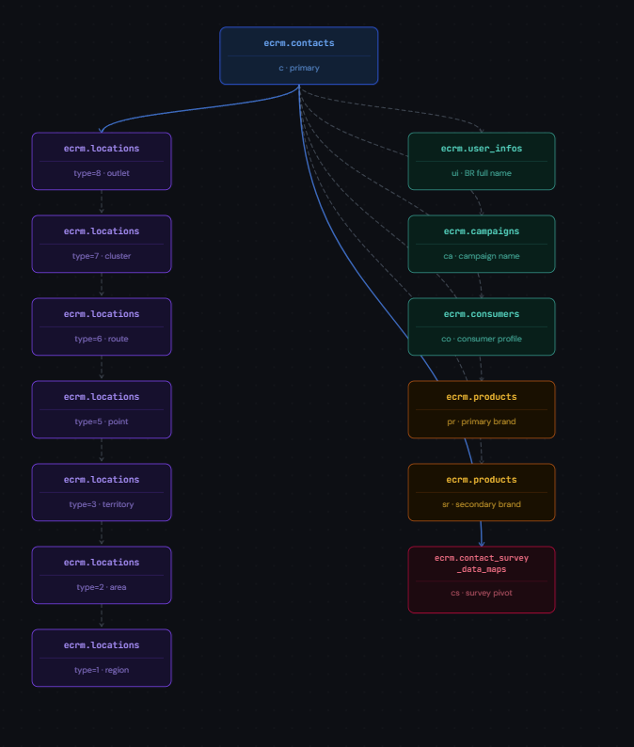

Visual Representation of the Connection (Live Observation)
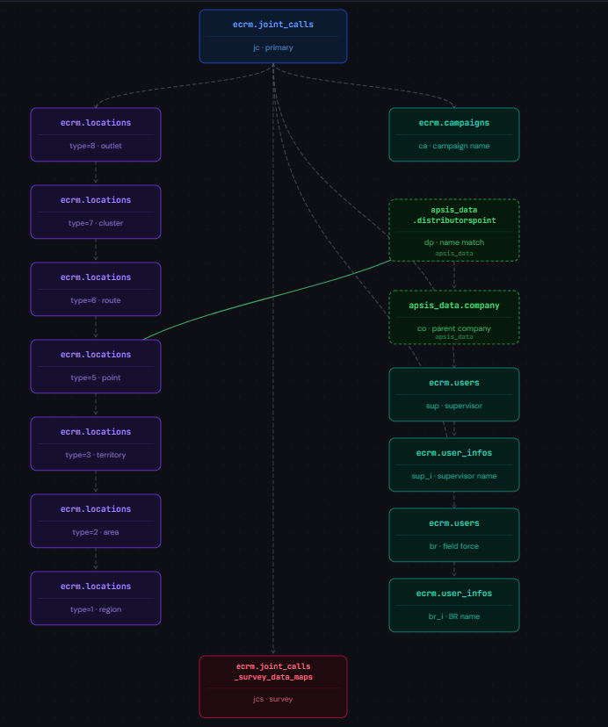

Visual Representation of the Connection (Call Checkback)

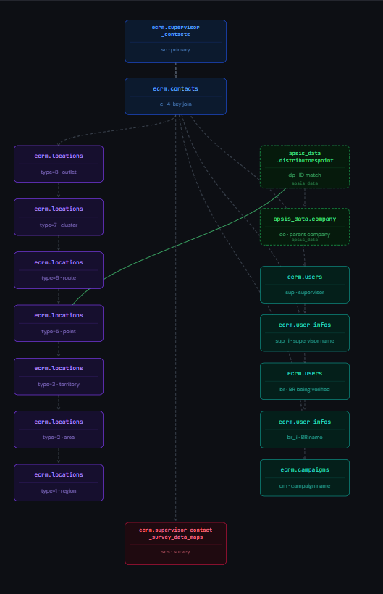

Visual Representation of the Connection (Call Checkback)
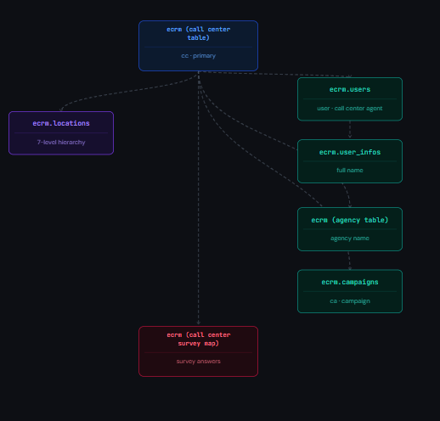

All Report Visual Together:

